**Student Instructions for Video Tutoring**

1. Requirements
2. You must have a Windows Live account as well as Windows Live Messenger to participate in video tutoring.
3. Internet access at home.
4. WebCam, and Speakers. (Microphone is not required, but preferable.)

To begin, open Windows Live Messenger. If you do not have Windows Live Messenger, or a windows live email account, you must download Windows Live Messenger and create an account. To get Messenger and set up a Windows Live account go to <http://www.windowslive.com>.

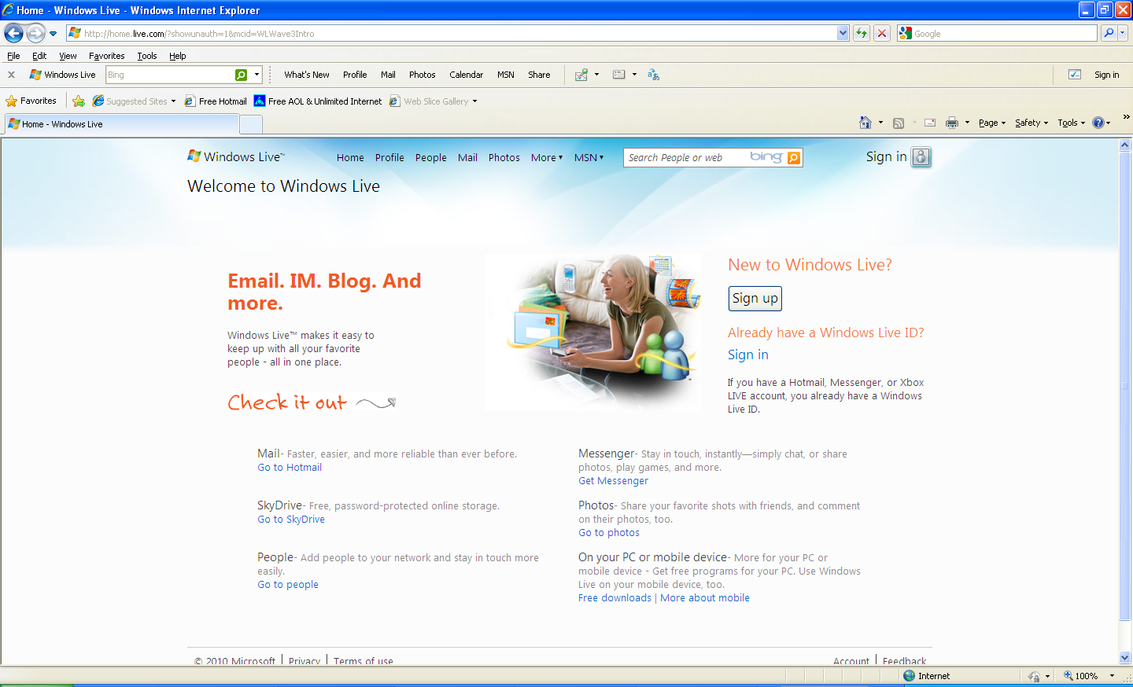

Click on the sign up button to sign up for an account. Click the get messenger link to navigate to the page where you can download Windows Live Messenger.

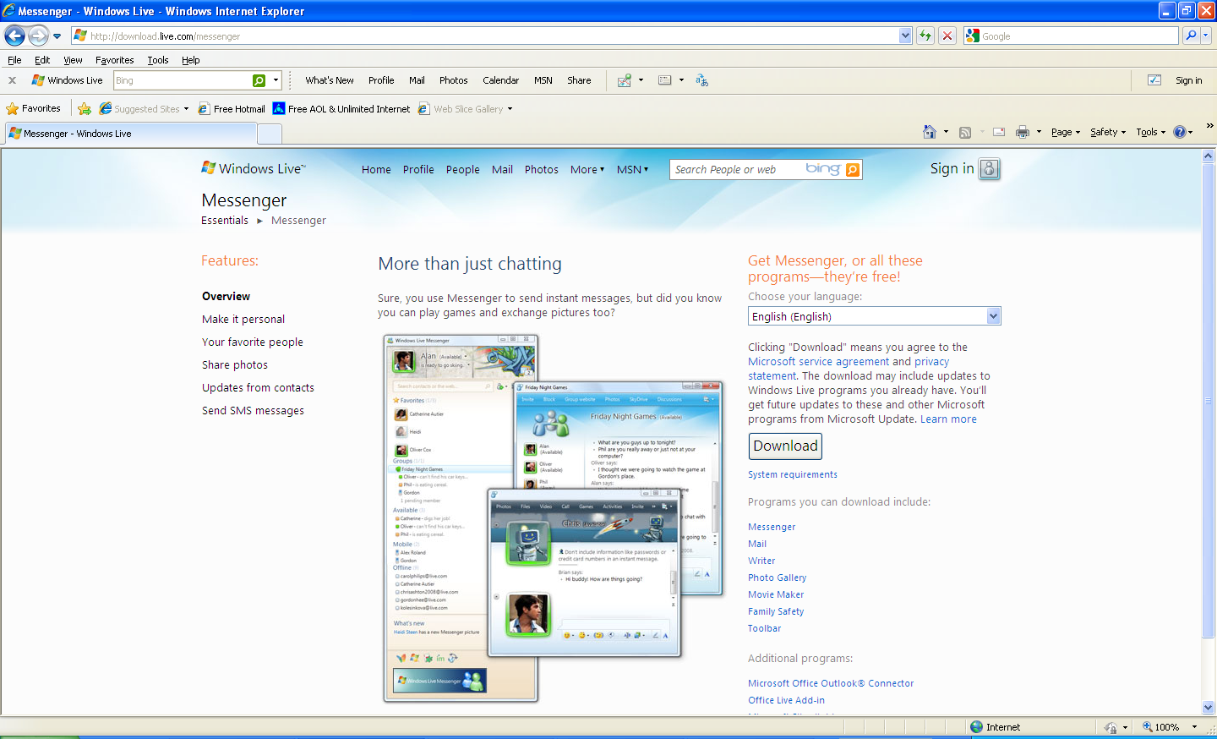

Click on the download button to download and install messenger.

Note: All students attending DeVry University have a school email account which is a Windows Live email account. To find your user name and password for your DeVry email account go to the student portal at <http://my.devry.edu> and login. Click on the My Student Email link in the DV Student Tools Box near the top of the screen. You may use this email address to login to Windows Live Messenger.

Login to Messenger and click the add contact or group button, and click add contact. To add the Academic Success Center to your list of contacts, type in the email address [ASCTutoring@hotmail.com](mailto:ASCTutoring@hotmail.com) and click next.

**Students must make appointments for video tutoring.**

In order to be added to the ASC contact list and to make appointments for video tutoring please email [djohnston@devry.edu](mailto:djohnston@devry.edu). Confirm the day and time for the appointment.

To start a video tutoring session, login to Windows Live Messenger.

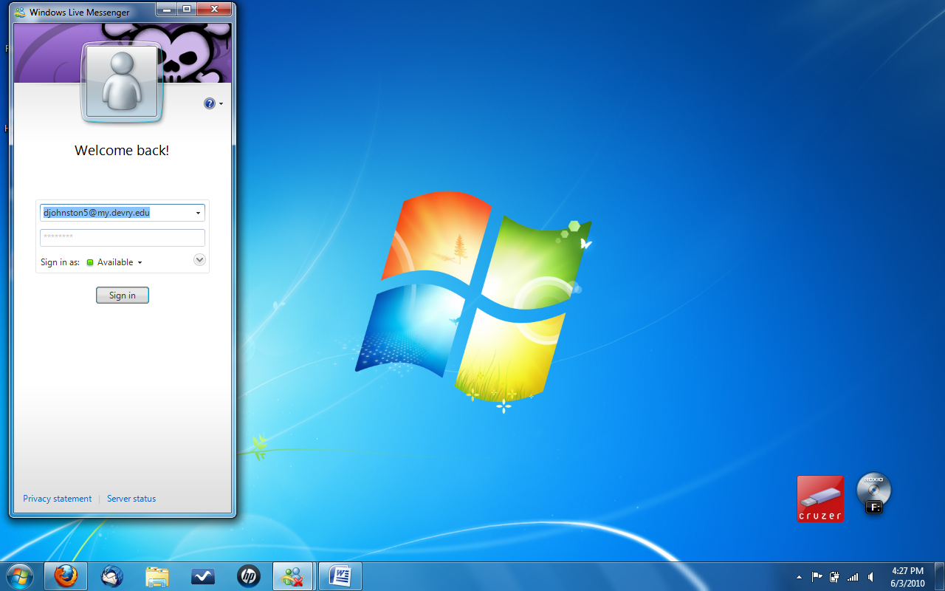

Double click on Academic Success Center in your contact list.

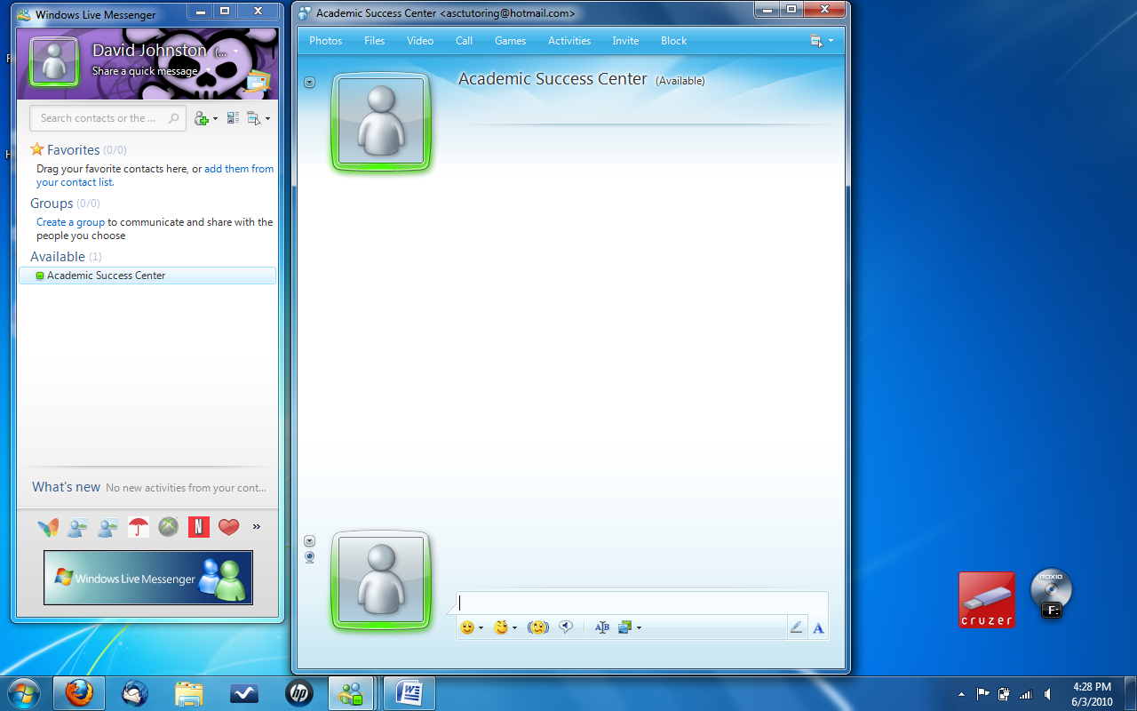

At the top of the screen click the video button. This will make a video call to the ASC. When the call is answered the tutoring session will begin.  
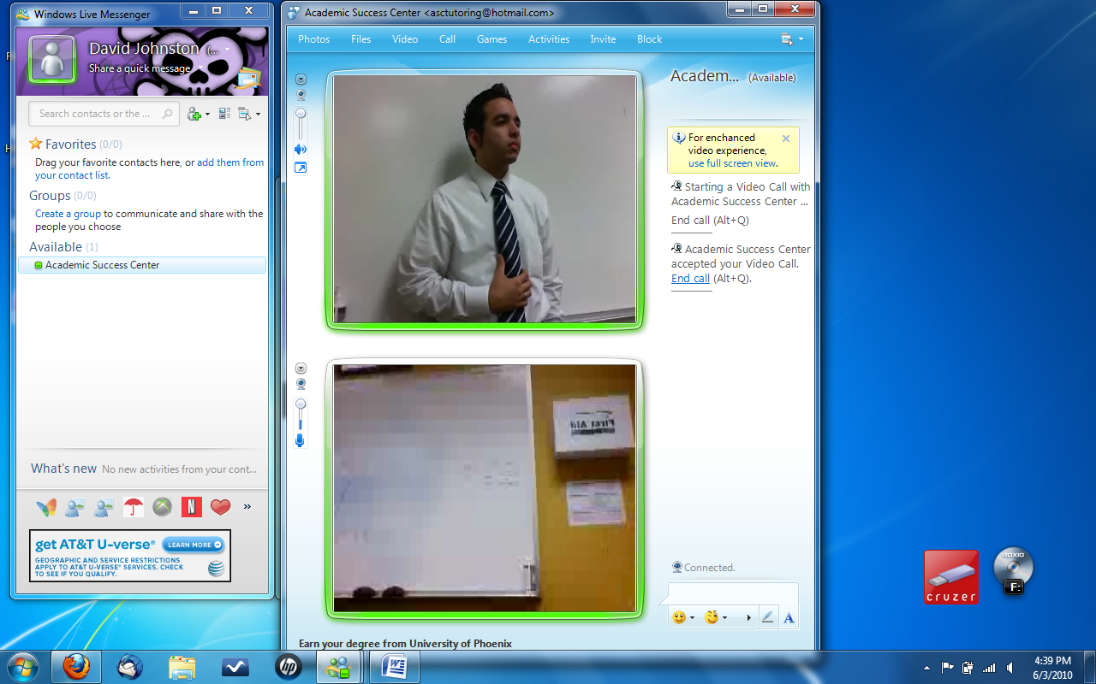

The top screen shows the Academic Support Center. You can enlarge the view by clicking the Full Screen button, which is the bottom button to the left of top picture.

To end the call simply click on end call.

Note: If you need any further instruction or help with this process, please come to the Academic Success Center(ASC) and we will gladly help you.